**EXP NO 9** Create a simple cloud web application for student counselling system using any Cloud Service Provider to demonstrate SaaS with the fields of student name, age, address, phone, subjects studied, Year of passing, percentage of marks, domain interest, etc.

**AIM:**

TO create a simple cloud software application for online student Counselling system using any cloud service provider to demonstrate saas.

**PROCEDURE:**

**STEP1:** GOTO ZOHO.COM STEP

**STEP2:** LOGIN TO THE ZOHO.COM STEP

**STEP 3**: SELECT ONE APPLICATION STEP

**STEP 4:** ENTER APPLICATION NAME STEP

**STEP 5:** CREATED NEW APPLICATION STEP

**STEP 6:** SELECT ONE FORM STEP

**STEP 7:** THE SOFTWARE HASE BEEN CREATE

**PROCEDURE**

**STEP 1** GO TO ZOHO.COM

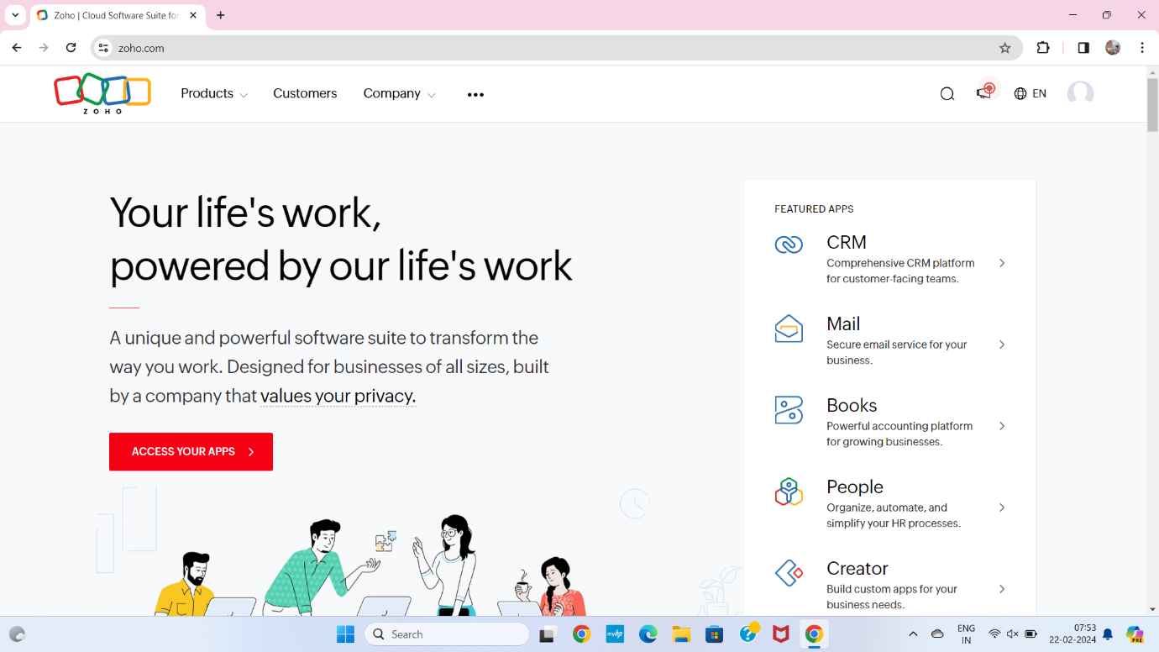

**STEP2** LOGIN TO THE ZOHO.COM

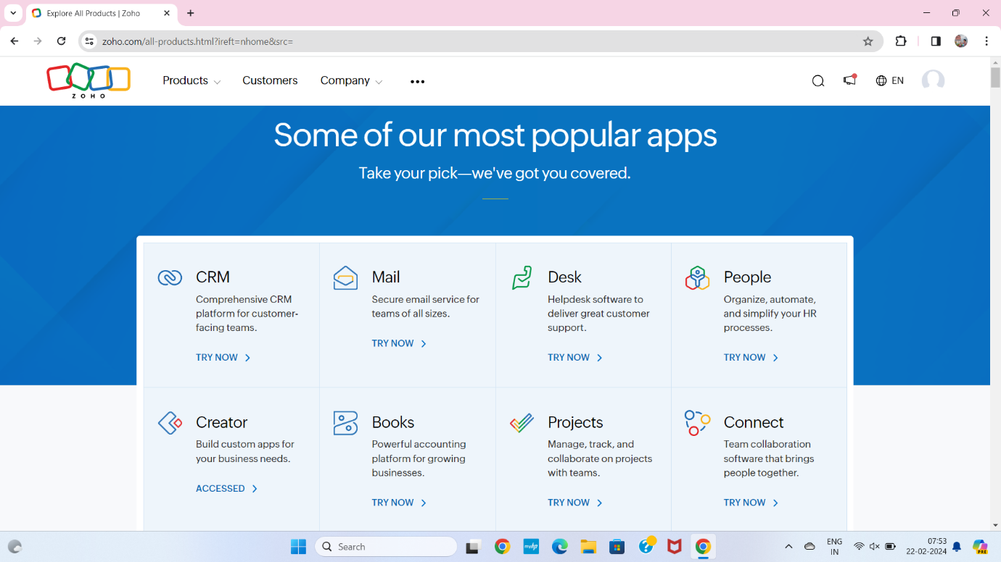

**STEP 3** SELECT A CREATE FROM SCRATCH

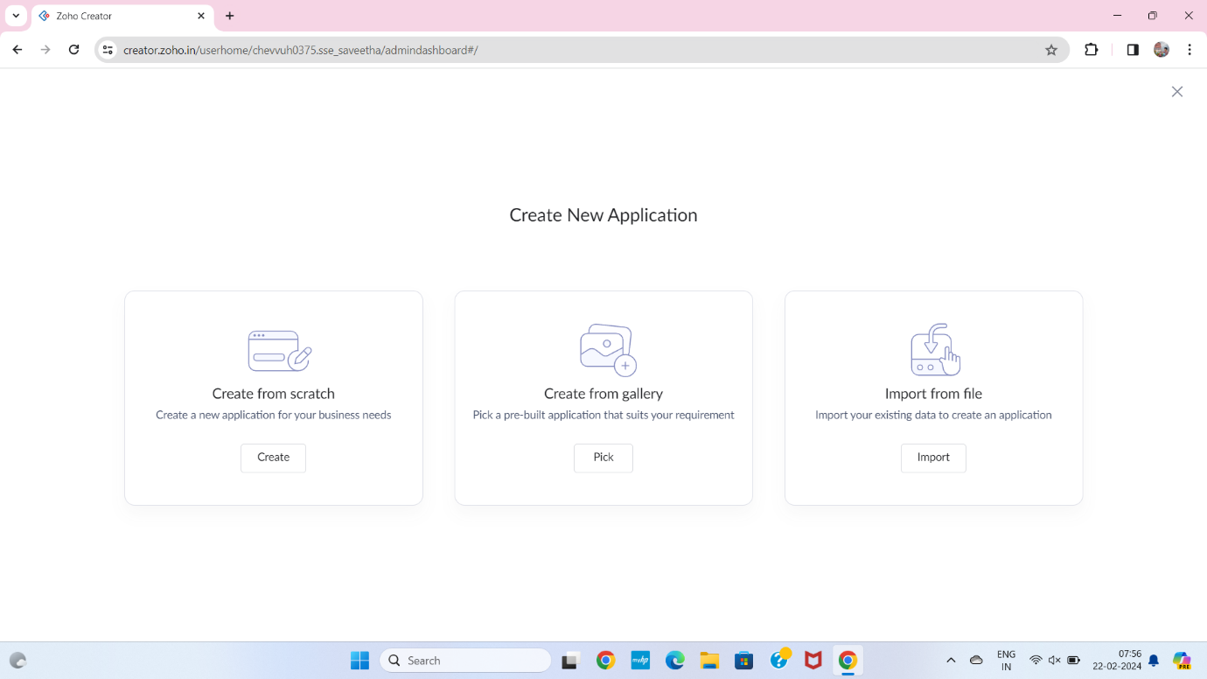

**STEP 4** SELECT APPLICATION NAME AS STUDENT COUNCELLING SYSTEM

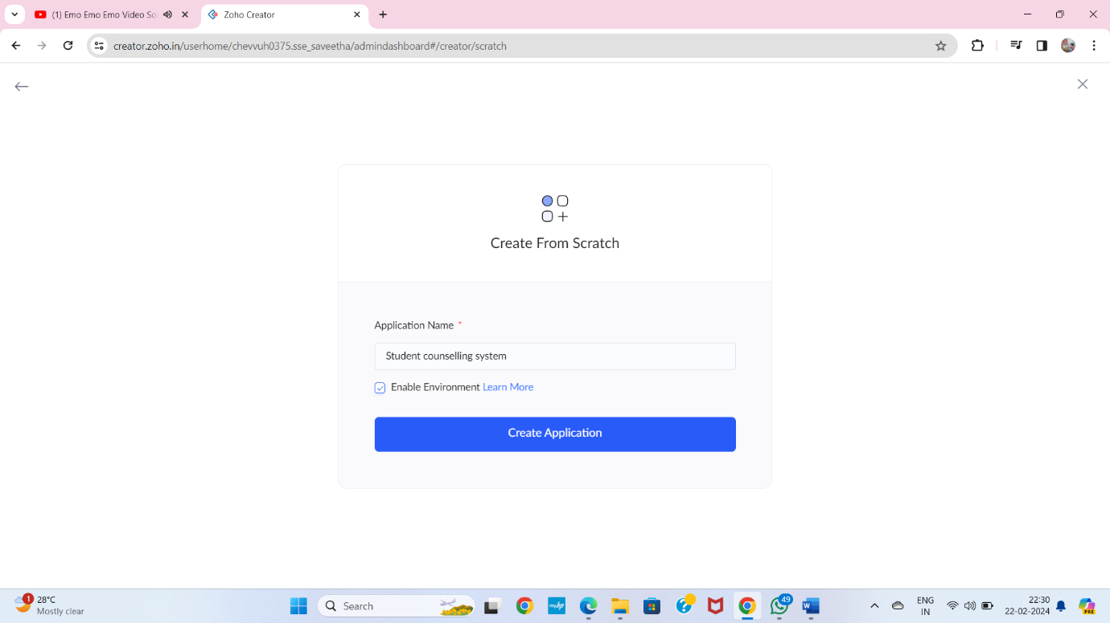

**STEP 5** CREATE A NEW FORM

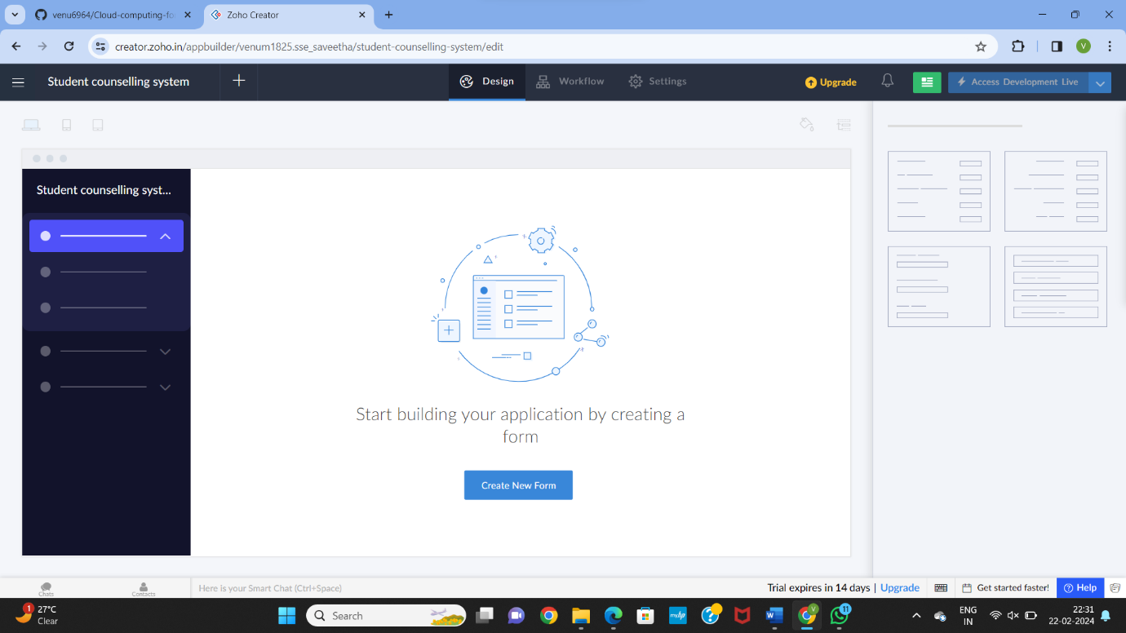

**STEP 6** SELECT BASIC FIELD FROM GIVEN BELOW AND DEVELOP APPLICATION

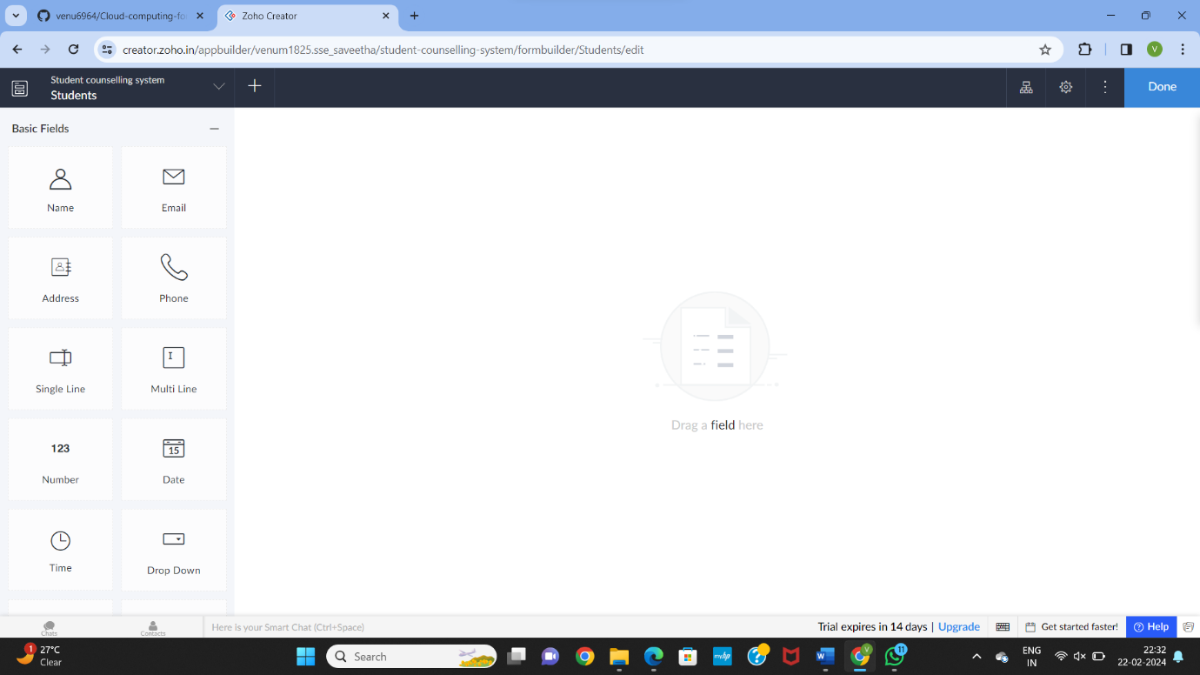

**STEP 7** THE SOFTWARE HASE BEEN CREATED STUDENT

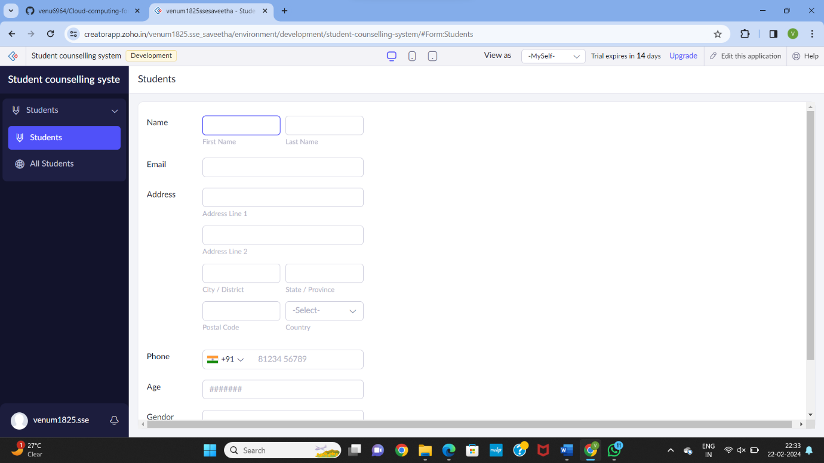

**STEP 8** THE SOFTWARE HASE BEEN CREATED STUDENT COLLAGING

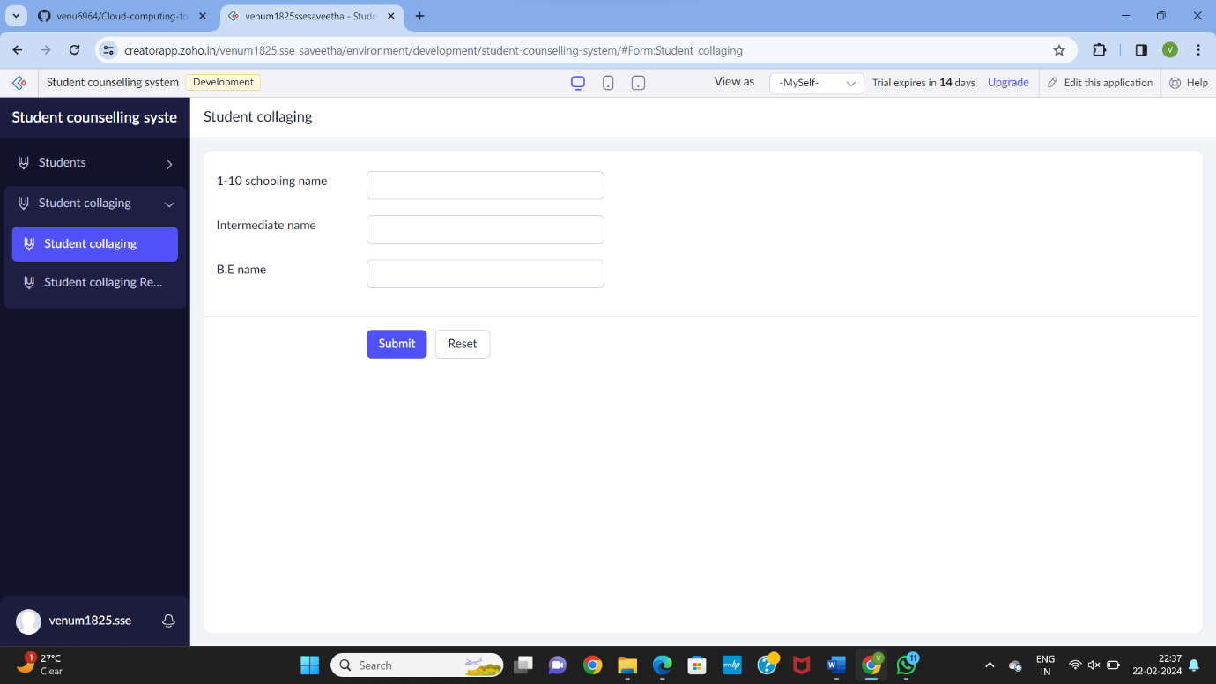

**STEP 9** THE SOFTWARE HASE BEEN CREATED STUDENT MARKS

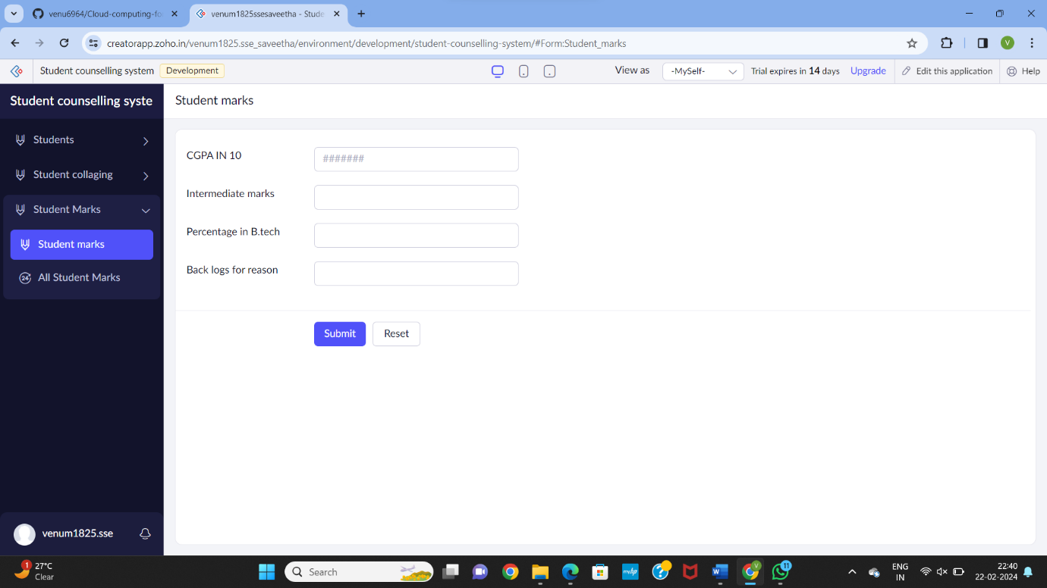

**STEP 10** THE SOFTWARE HASE BEEN CREATED DOMAIN INTERE

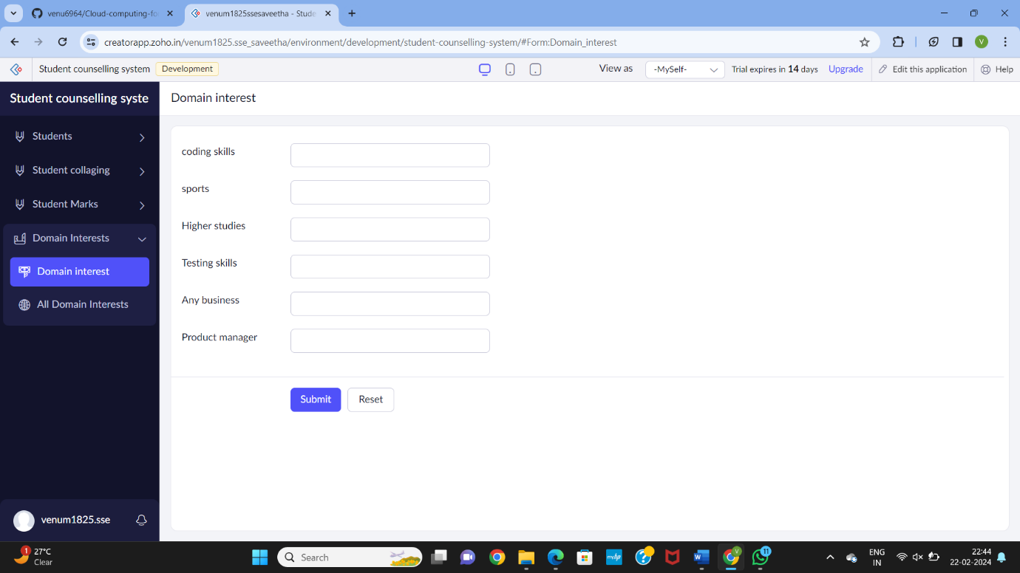

**STEP 10** THE SOFTWARE HASE BEEN CREATED

